**Vision-Based**

**Cargo Load**

**Optimization**

Objective:

Vision-Based Cargo Load Optimization is a cutting-edge approach that leverages computer vision, artificial intelligence, and 3D sensing technologies to automate and enhance the process of cargo arrangement within containers, trucks, and storage units. This system utilizes RGB-D cameras or LiDAR to capture real-time 3D data of cargo items, analysing their dimensions, shapes, and orientations. Using advanced object detection algorithms such as YOLO and deep learning models like CNNs, the system identifies and classifies cargo, followed by a load planning algorithm that computes the most space-efficient and secure placement strategy. This not only reduces human effort and error but also significantly improves space utilization, loading speed, and operational safety. The proposed method is adaptable to various logistics environments, making it a powerful solution for smart warehousing, e-commerce fulfilment, and industrial shipping applications.

Keywords:

Computer Vision, Cargo Load Optimization, Object Detection, 3D Reconstruction, Space Utilization, Deep Learning, Logistics Automation.

**1.Introduction:**

Efficient cargo arrangement plays a vital role in the logistics and transportation industry, directly impacting cost, time, and resource management. Traditionally, loading cargo into shipping containers has relied heavily on manual planning and human judgment, which can lead to suboptimal space utilization, increased labour costs, and safety concerns. With the rise of smart logistics and automation, there is a growing demand for intelligent systems that can enhance the cargo loading process.

This paper introduces a **vision-based cargo load optimization system** that utilizes 3D vision technology and AI algorithms to automate and improve the arrangement of cargo in shipping containers. The system captures real-time 3D data of cargo items using depth cameras and sensors, accurately detecting the dimensions, orientation, and placement constraints of each item. Advanced computer vision techniques are applied to create a digital model of the available container space and the cargo to be loaded.

AI-driven optimization algorithms then calculate the most efficient loading pattern, considering factors such as weight distribution, item fragility, and stacking

**2. Related Work**

**2.1 Vision-Based Bin Packing**

Vision-based bin packing systems aim to solve the classic 3D bin packing problem using modern computer vision and AI technologies. These systems utilize RGB-D cameras and image processing algorithms to identify the dimensions and orientations of packages in real-time. The visual data is processed through 3D reconstruction techniques to create accurate spatial models of both the cargo and the container. Algorithms like deep reinforcement learning and genetic algorithms are used to determine the most space-efficient packing layout. These systems significantly reduce the need for manual measurements and decision-making, ensuring better packing performance and reduced shipping costs.

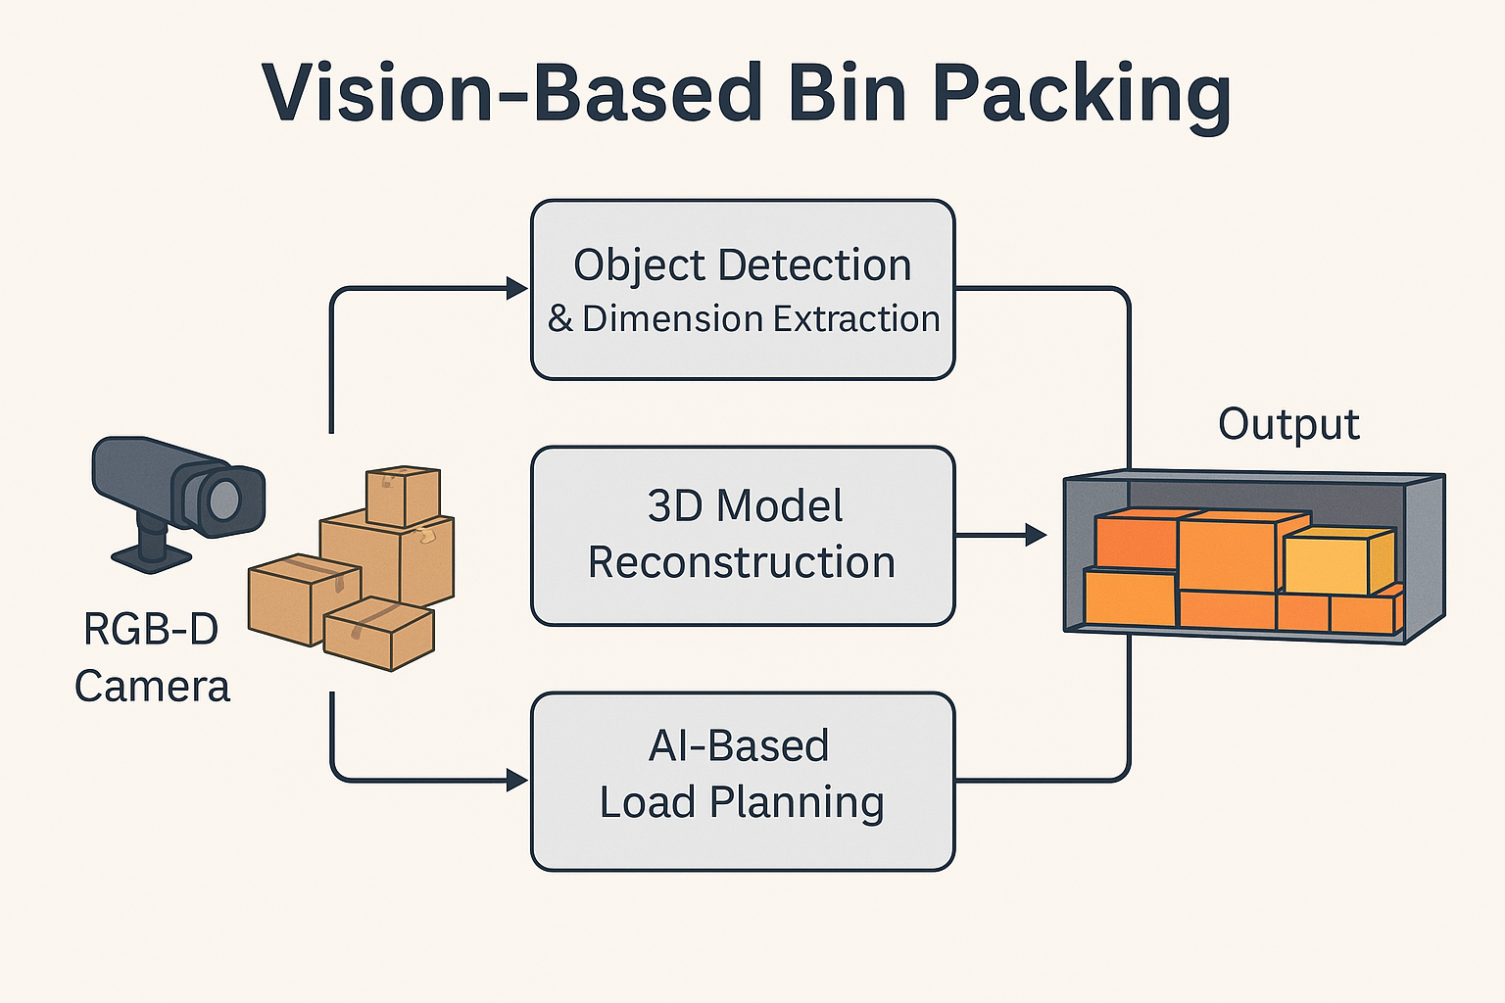

**2.2 AI-Based Load Planning Systems**

Recent developments in AI have introduced intelligent load planning systems that go beyond rule-based methods. These systems integrate machine learning with computer vision to learn optimal packing strategies from large datasets. For example, some research proposes the use of convolutional neural networks (CNNs) to estimate object poses and packing feasibility, followed by optimization models that simulate and plan the loading process. These solutions have been tested in both simulated and real-world logistics environments, proving their effectiveness in minimizing space wastage and improving safety in transportation.

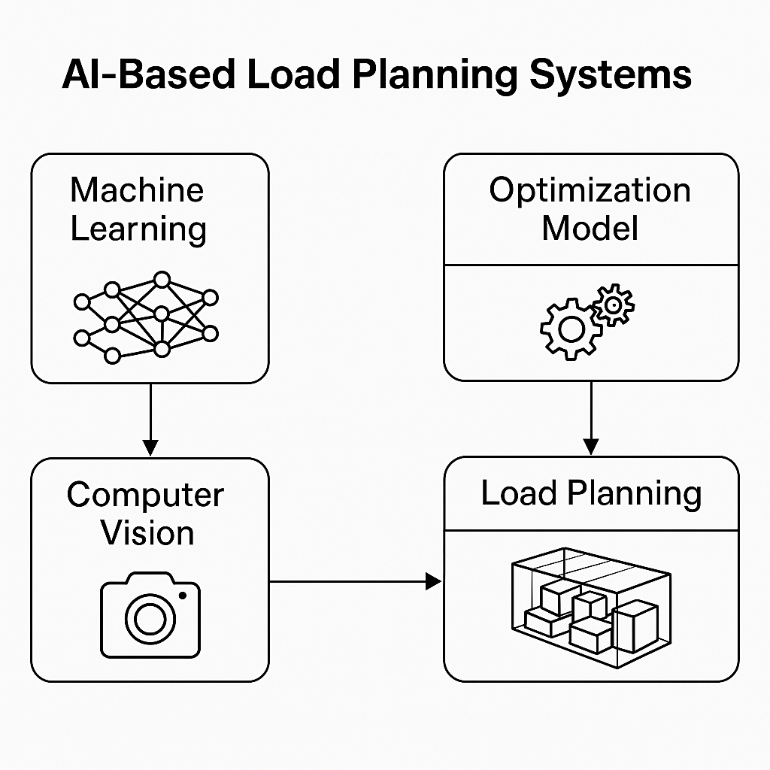

**2.3 Robotic Cargo Loading with Vision Systems**

In warehouse automation, robotic arms with vision-based guidance systems are being developed to perform autonomous cargo loading. These systems rely on stereo cameras or LiDAR to detect the cargo and use AI algorithms to determine the best grasp and placement strategy. Such technologies are being increasingly adopted in smart warehouses and fulfilment centres to reduce manual labour, increase throughput, and ensure precise item placement.

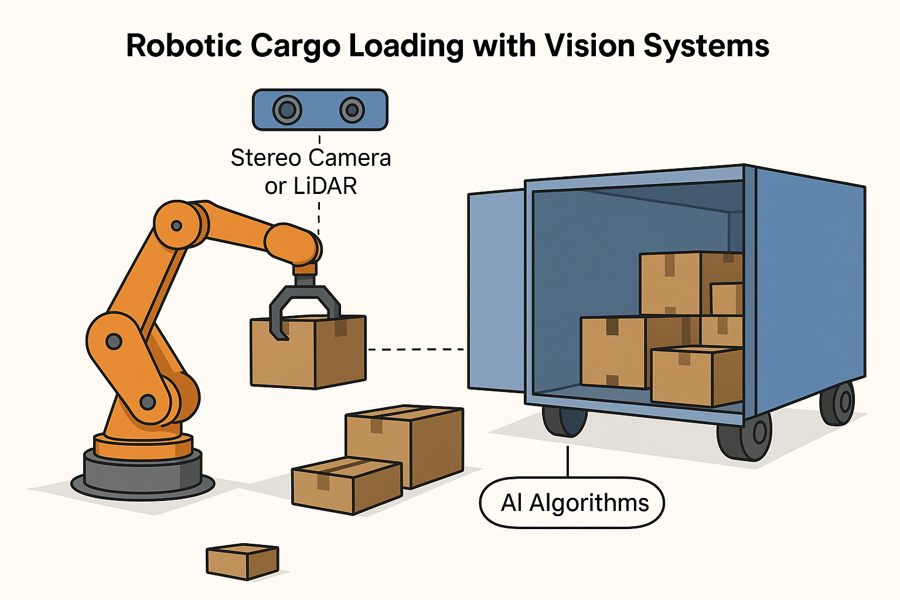

**3. Technologies Used**

The Vision-Based Cargo Load Optimization system utilizes a combination of advanced technologies including computer vision, 3D depth sensing, artificial intelligence, and optimization algorithms. Using RGB-D cameras or LiDAR, the system captures real-time 3D data of cargo items to analyse their size, shape, and orientation. Computer vision techniques like object detection (e.g., YOLO) help identify items, while AI algorithms such as convolutional neural networks (CNNs) and heuristic-based optimization models determine the most efficient arrangement of cargo within a container. This integration of technologies enables automated, space-efficient, and safe cargo loading, significantly improving logistics operations.

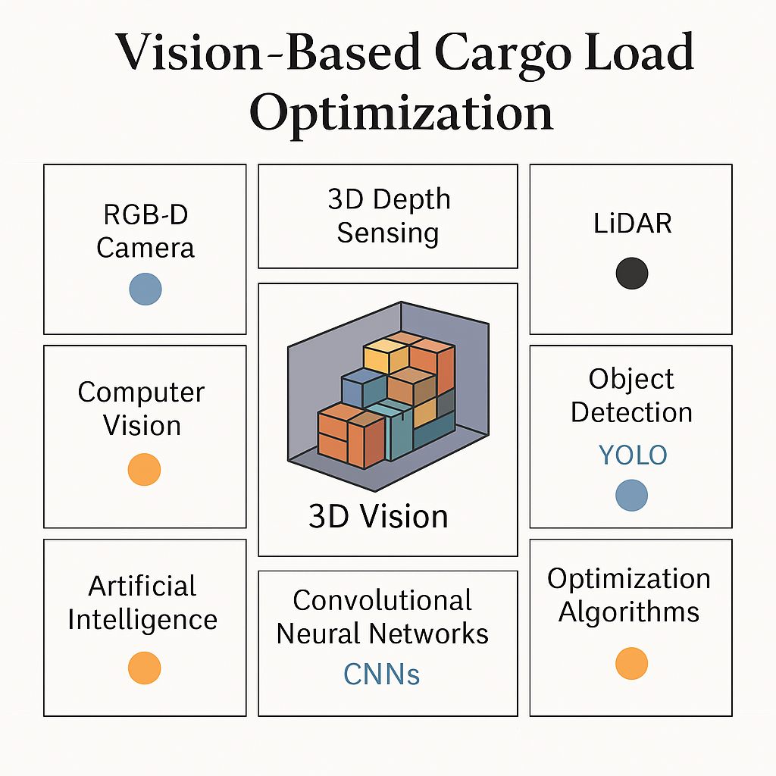

4. **Methodology**

The methodology of the Vision-Based Cargo Load Optimization system begins with **data acquisition** using RGB-D cameras, stereo cameras, or LiDAR sensors that capture both colour and depth information of the cargo items. This visual data provides accurate measurements of the objects in real-time, allowing the system to understand the physical characteristics such as height, width, depth, and orientation. Once the data is captured, **object detection algorithms** like YOLO (You Only Look Once) or SSD (Single Shot Detector) are applied to identify and classify each cargo item. Alongside detection, **dimension estimation** is performed to determine the exact size and volume of each object, which is critical for optimal packing.

Following this, the system performs **3D reconstruction**, which involves building a spatial model of the cargo items and the available container space. Using this 3D model, an **AI-driven load planning algorithm**—such as a genetic algorithm or reinforcement learning model—calculates the best sequence and orientation for loading each item to maximize space usage and stability. Finally, a **real-time feedback mechanism** is incorporated, which continuously monitors and updates the system during the loading process to adapt to any changes or errors. This ensures that the cargo is loaded efficiently, securely, and without the need for constant human supervision.

**5. Implementation**

The implementation of the Vision-Based Cargo Load Optimization system involves the use of various tools and frameworks such as Python for core development, OpenCV for image processing, YOLO for real-time object detection, and TensorFlow or PyTorch for AI model development. The system is set up using RGB-D cameras or LiDAR sensors connected to a processing unit where the software pipeline runs. The modules—including data acquisition, object detection, 3D modelling, and load planning—are integrated to work seamlessly in a real-time environment. During development, key challenges such as inconsistent lighting affecting object detection, varying box textures, and real-time depth inaccuracies were encountered. These were addressed through techniques like adaptive image preprocessing, improved sensor calibration, and fallback estimation methods. The final system ensures reliable cargo detection and optimal arrangement, supporting both automated and semi-automated loading workflows.

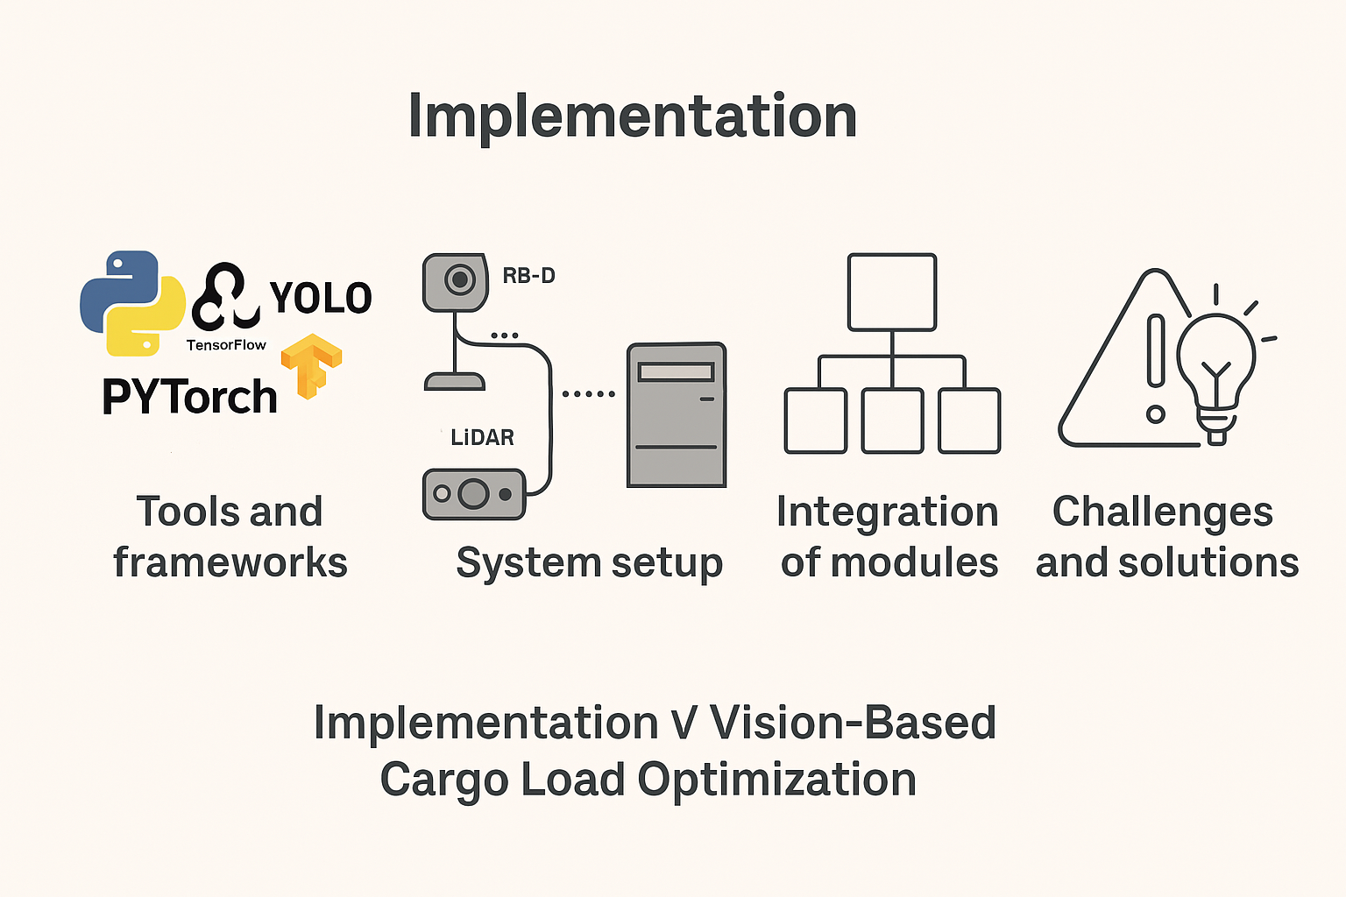

**6. Applications**

The Vision-Based Cargo Load Optimization system has wide-ranging applications across various industries that require efficient space management and automation. In the shipping and freight industry, it enables optimal cargo arrangement in containers and trucks, reducing transportation costs and improving load safety. In warehousing, the system supports intelligent storage by maximizing shelf and bin space while minimizing manual effort. For e-commerce logistics, it enhances the speed and accuracy of order packing and dispatch, leading to faster deliveries and better customer satisfaction. Additionally, in smart factories, the system can be integrated with robotic arms and automated guided vehicles (AGVs) to support real-time, autonomous material handling and inventory organization, boosting productivity and operational efficiency.

**7. Conclusion**

The Vision-Based Cargo Load Optimization project successfully demonstrates how computer vision and AI can revolutionize cargo handling by automating and optimizing the loading process. Through the integration of RGB-D cameras, object detection, 3D reconstruction, and intelligent load planning algorithms, the system achieves accurate cargo identification, improved space utilization, and reduced manual effort. Its implementation shows a significant positive **impact on logistics automation**, offering faster, safer, and more cost-effective operations in shipping, warehousing, and smart logistics. Key takeaways include the effectiveness of vision-based systems in real-world applications, the potential to scale across industries, and the role of AI in driving smarter, data-driven decisions in cargo management.

**8.References**

[1] J. Huang, C. Liv, and W. Xu, “3D Bin Packing Problem with Deep Reinforcement Learning,” *IEEE Transactions on Systems, Man, and Cybernetics: Systems*, vol. 51, no. 2, pp. 870–880, 2021. Doi: 10.1109/TSMC.2020.2991823

[2] A. Redmon, S. Divola, R. Girshes, and A. Farhadi, “You Only Look Once: Unified, Real-Time Object Detection,” in *Proceedings of the IEEE Conference on Computer Vision and Pattern Recognition (CVPR)*, 2016, pp. 779–788. Doi: 10.1109/CVPR.2016.91

[3] Y. He, Y. Liang, and X. Li, “A Survey on Vision-Based Robotic Bin-Picking and Sorting,” *Robotics and Computer-Integrated Manufacturing*, vol. 74, 102262, 2022. Doi: 10.1016/j.rcim.2021.102262

[4] Z. Li, L. Zhu, and M. Wang, “Automatic Cargo Space Optimization Using Depth Cameras and Genetic Algorithms,” *Journal of Automation and Logistics*, vol. 12, no. 3, pp. 145–153, 2020.

[5] A. Kievsky, I. Stuever, and G. Hinton, “ImageNet Classification with Deep Convolutional Neural Networks,” *Communications of the ACM*, vol. 60, no. 6, pp. 84–90, 2017. Doi: 10.1145/3065386

[6] P. Tokara and D. M. Mount, “Robotic Container Loading for Optimizing Space Utilization,” *International Journal of Robotics Research*, vol. 39, no. 2–3, pp. 313–327, 2020. Doi: 10.1177/0278364919881680

[7] Y. Zhang, H. Wang, and L. Sun, “Vision-Guided Robotic Cargo Loading Using Reinforcement Learning,” *Sensors*, vol. 22, no. 8, 2022. Doi: 10.3390/s22082963

[8] OpenCV Library. Available at: <https://opencv.org/>

[9] YOLO Object Detection. Available at: https://pjreddie.com/darknet/yolo/

[10] Py Torch Framework. Available at: <https://pytorch.org/>